set ns [new Simulator]

set nf [open out.nam w]

$ns namtrace-all $nf

set tr [open out.tr w]

$ns trace-all $tr

proc finish {} {

global nf ns tr

$ns flush-trace

close $tr

exec nam out.nam &

exit 0

}

set n0 [$ns node]

set n1 [$ns node]

set n2 [$ns node]

set n3 [$ns node]

$ns duplex-link $n0 $n1 10Mb 10ms DropTail

$ns duplex-link $n1 $n3 10Mb 10ms DropTail

$ns duplex-link $n2 $n1 10Mb 10ms DropTail

$ns duplex-link-op $n0 $n1 orient right-down

$ns duplex-link-op $n1 $n3 orient right

$ns duplex-link-op $n2 $n1 orient right-up

set tcp [new Agent/TCP]

$ns attach-agent $n0 $tcp

set ftp [new Application/FTP]

$ftp attach-agent $tcp

set sink [new Agent/TCPSink]

$ns attach-agent $n3 $sink

set udp [new Agent/UDP]

$ns attach-agent $n2 $udp

set cbr [new Application/Traffic/CBR]

$cbr attach-agent $udp

set null [new Agent/Null]

$ns attach-agent $n3 $null

$ns connect $tcp $sink

$ns connect $udp $null

$ns rtmodel-at 1.0 down $n1 $n3

$ns rtmodel-at 2.0 up $n1 $n3

$ns rtproto LS

$ns at 0.0 "$ftp start"

$ns at 0.0 "$cbr start"

$ns at 5.0 "finish"

$ns run

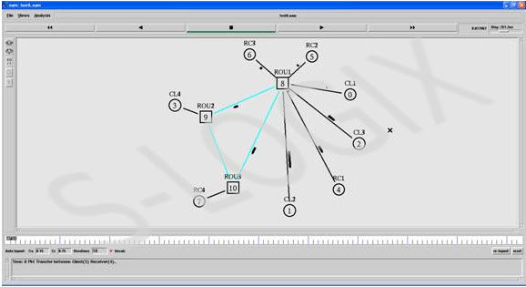

**Postlabs:**

GATE -CS-2010

Consider a network with 6 routers R1 to R6 connected with links having weights as shown in the following diagram

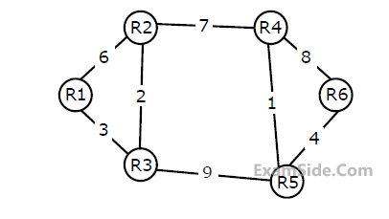

All the routers use the distance vector based routing algorithm to update their routing tables. Each router starts with its routing table initialized to contain an entry for each neighbour with the weight of the respective connecting link. After all the routing tables stabilize, how many links in the network will never be used for carrying any data?

Solution:

We can check one by one all shortest distances. When we check for all shortest distances for Ri we don’t need to check its distances to R0 to Ri-1 because the network graph is undirected.  
Following will be distance vectors of all nodes.

Shortest Distances from R1 to R2, R3, R4, R5 and R6  
R1 (5, 3, 12, 12, 16)  
Links used: R1-R3, R3-R2, R2-R4, R3-R5, R5-R6

Shortest Distances from R2 to R3, R4, R5 and R6  
R2 (2, 7, 8, 12)  
Links used: R2-R3, R2-R4, R4-R5, R5-R6

Shortest Distances from R3 to R4, R5 and R6  
R3 (9, 9, 13)  
Links used: R3-R2, R2-R4, R3-R5, R5-R6

Shortest Distances from R4 to R5 and R6  
R4 (1, 5)  
Links used: R4-R5, R5-R6

Shortest Distance from R5 to R6  
R5 (4)  
Links Used: R5-R6

If we mark, all the used links one by one, we can see that following links are never used.  
R1-R2  
R4-R6